 | Assignment No. 02  SEMESTER Spring 2021  CS403- Database Management System | Total Marks: 20  Due Date: 7th June, 2021
Solution

NAME: TAMKEEN SAJJAD
ID: MC200400003

Course: MIT

- Draw the Entity Relationship diagram.
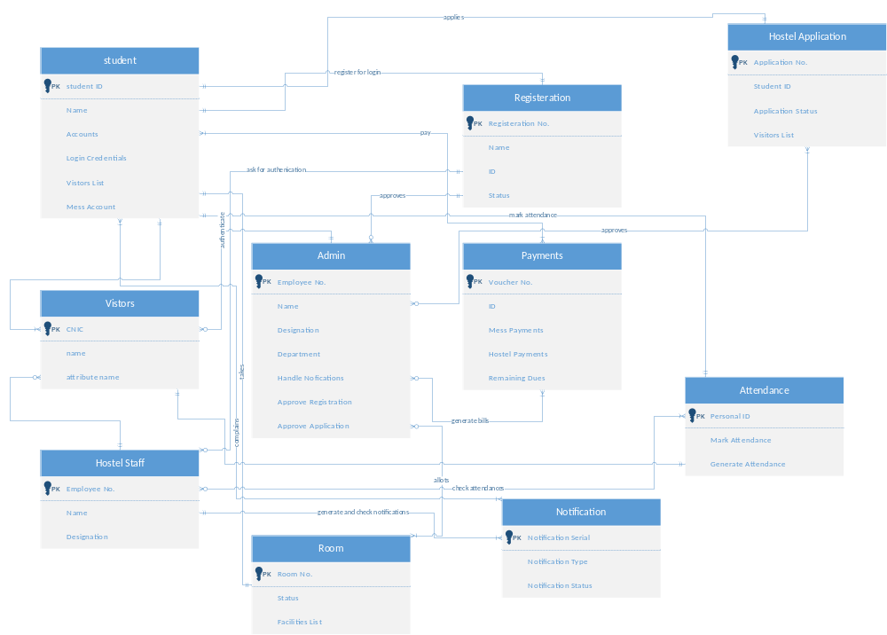

- Draw relationship cardinalities in alphabetical notation.

